Metabolomics: PAH plasma metabolites in MoTrPAC context
This guide starts from a public PAH metabolomics study (ST000763), analyses it, and maps its metabolites onto healthy MoTrPAC blood and muscle metabolomics. It compares separate studies. It does not test whether exercise treats PAH.

Data prep
ST000763 was downloaded from the Metabolomics Workbench on 25 September 2026 as factors.json (sample labels) and data.json (metabolite values), saved in data/workbench/ST000763/. It is systemic sclerosis (SSc) with and without PAH; the study page says blood was drawn "at rest and again at peak exercise for each human subject". 218 samples, 673 metabolite features (552 unique RefMet names). Values are "Peak area normalized", and every test uses log2 values.
Each sample has four labels: Exercise (No = rest, Yes = peak), Group, Sex and Type. Type matters: every PAH, borderline and normal-pressure sample is Cath (drawn in the catheterization setting), and every healthy and low-risk SSc sample is Non-invasive.
Group | Setting | Rest | Peak | Inferred pairs
Healthy | Non-invasive | 37 | 37 | 37
Low-risk SSc | Non-invasive | 22 | 22 | 22
Normal pressures (SSc) | Cath | 10 | 10 | 10
Borderline pressures (SSc) | Cath | 21 | 21 | 21
SSc-PAH | Cath | 20 | 18 | 18

So PAH versus healthy always mixes PAH, scleroderma and sampling setting. The same-setting comparison is PAH versus normal-pressure SSc.
No participant IDs. A rest sample is paired with the next-numbered peak sample from the same group, sex and setting: 108 inferred pairs. Plausible, not verified.
MoTrPAC input: the MotrpacHumanPreSuspensionAnalysis 2.0.8 R package (collection c2.0). Three precomputed endurance contrasts are used:
Contrast | Meaning | Use here
EE-CON | (exercise post − pre) − (control post − pre) | the exercise effect
EE-EE | exercise post − pre only | like-for-like with patient peak − rest
CON-CON | control post − pre only | drift without exercise (fasting, time of day)

data/refmet/ holds the RefMet metabolite-class list from the MoTrPAC package source. data/source_manifest.json stores each input's SHA-256 hash.

Scripts
PAH data: What differs in PAH?
0. 00_verify_inputs.py checks the input hashes, 218 samples and 673 features.
1. 01_prepare_st000763.py reads labels and values, builds the 108 inferred pairs, and writes 01_st000763_samples.csv, 01_inferred_pairs.csv and 01_group_setting_counts.csv (the table above). The log2 matrix is saved in data/processed/ for later scripts.
2. 02_compare_exercise_response.py: does exercise change a metabolite differently in PAH? For each pair, change = log2(peak) − log2(rest). A Welch t test compares groups, e.g. (PAH peak − rest) − (healthy peak − rest), with BH correction. 560 eligible metabolites, 0 with q < 0.05 (smallest q 0.84). Only 17 have raw P < 0.05, fewer than the ~28 expected by chance. PAH versus normal-pressure, borderline or all SSc without PH also gives 0. Within PAH alone, four change: succinic acid rises (+0.75 log2) and three long-chain fatty acids fall. Succinate also rises in healthy people, so it is an exercise response, not a PAH one. No MoTrPAC data here.
- This is the like-for-like PAH-versus-healthy test: same study, platform and exercise test. It is not the MoTrPAC EE-CON formula; patients have no non-exercising control group.
3. 03_compare_resting_levels.py: do resting levels differ? Rest samples only, so no pairing.
- PAH vs healthy: 43 of 574 features at q < 0.05 (41 metabolites): 26 higher in PAH, mostly free fatty acids about 2–3-fold; 17 lower (triglycerides, phosphatidylcholines). Holds with rank-based testing (69), per-sample centering (45) and sex adjustment (37).
- PAH vs normal-pressure SSc (same Cath setting): 0. Normal → borderline → PAH trend: 0.
- Normal-pressure SSc already carries a median 90% of each PAH-versus-healthy difference (41 of 43 carry at least half).
Is the PAH-versus-healthy difference PAH, scleroderma, or where the blood was drawn? The data point to setting and/or scleroderma. One possible, unverified cause: heparin during catheterization releases free fatty acids from triglycerides.
MoTrPAC context: How do these metabolites behave in healthy people?
4. 04_export_motrpac_metabolomics.R exports MoTrPAC's precomputed EE-CON, EE-EE and CON-CON results: blood 1,143 features × 6 times, muscle 891 features × 3 times, 28,593 rows, each with logFC and BH-adjusted p value. No model is fitted; just the MoTrPAC csv (data/processed/motrpac_metabolite_contrasts.csv.gz).
5. 05_align_exercise_with_motrpac.py: how similar is each group's rest-to-peak change to MoTrPAC's change at 20 and 40 minutes (closest to peak)? Metabolites match by exact name: MoTrPAC refmet_name, or its feature_id when the RefMet name is blank (mostly lipids like "PC 40:4"). 340 names match (178 through feature_id). Spearman rho is descriptive only.
MoTrPAC contrast, 20 min | PAH (all) | Healthy (all) | PAH (RefMet-only) | Healthy (RefMet-only)
EE-CON | 0.24 | 0.12 | 0.44 | 0.27
EE-EE (like-for-like) | 0.08 | 0.19 | 0.29 | 0.30
CON-CON | −0.22 | −0.04 | −0.18 | −0.10

- With the like-for-like EE-EE, PAH is no more MoTrPAC-like than healthy.
- PAH's extra likeness under EE-CON comes from the control side: PAH changes run slightly opposite to MoTrPAC's resting-control drift, and subtracting that drift inflates the match.
6. 06_build_context_table.py adds MoTrPAC context to any PAH metabolite list in one standard format; it already includes script 03's resting list. Per metabolite: exercise effect by time, peak time, still changed at 3.5–24 h, largest control drift, muscle response, and a label. A label needs q < 0.05 and |log2 FC| ≥ 0.5 (about 1.4-fold); with q alone, 78% of all metabolites "drift" in MoTrPAC controls, which says nothing.
- 41 resting hits: 27 match MoTrPAC blood; 24 are "stable in MoTrPAC blood", 3 triglycerides "drift without exercise", 14 unmatched (e.g. arachidonic acid is only in MoTrPAC muscle).
- Hits are no more exercise-sensitive (0% vs 4.1%, Fisher P 0.61) or drift-sensitive (11% vs 6.8%, P 0.42) than the study's other matched metabolites.
- Resting differences are a median 3.1 times (range 1.1–16) MoTrPAC's largest control drift. Free fatty acids mostly ≥ 2.5 times; the three triglycerides only 1.3–1.6 times, so fasting or time of day could contribute to those.
7. 07_plot_resting_setting_effect.py plots the 12 strongest resting results in every group, relative to healthy. The three Cath groups sit together, far from healthy; low-risk SSc sits near healthy. PAH does not stand apart from normal-pressure SSc.
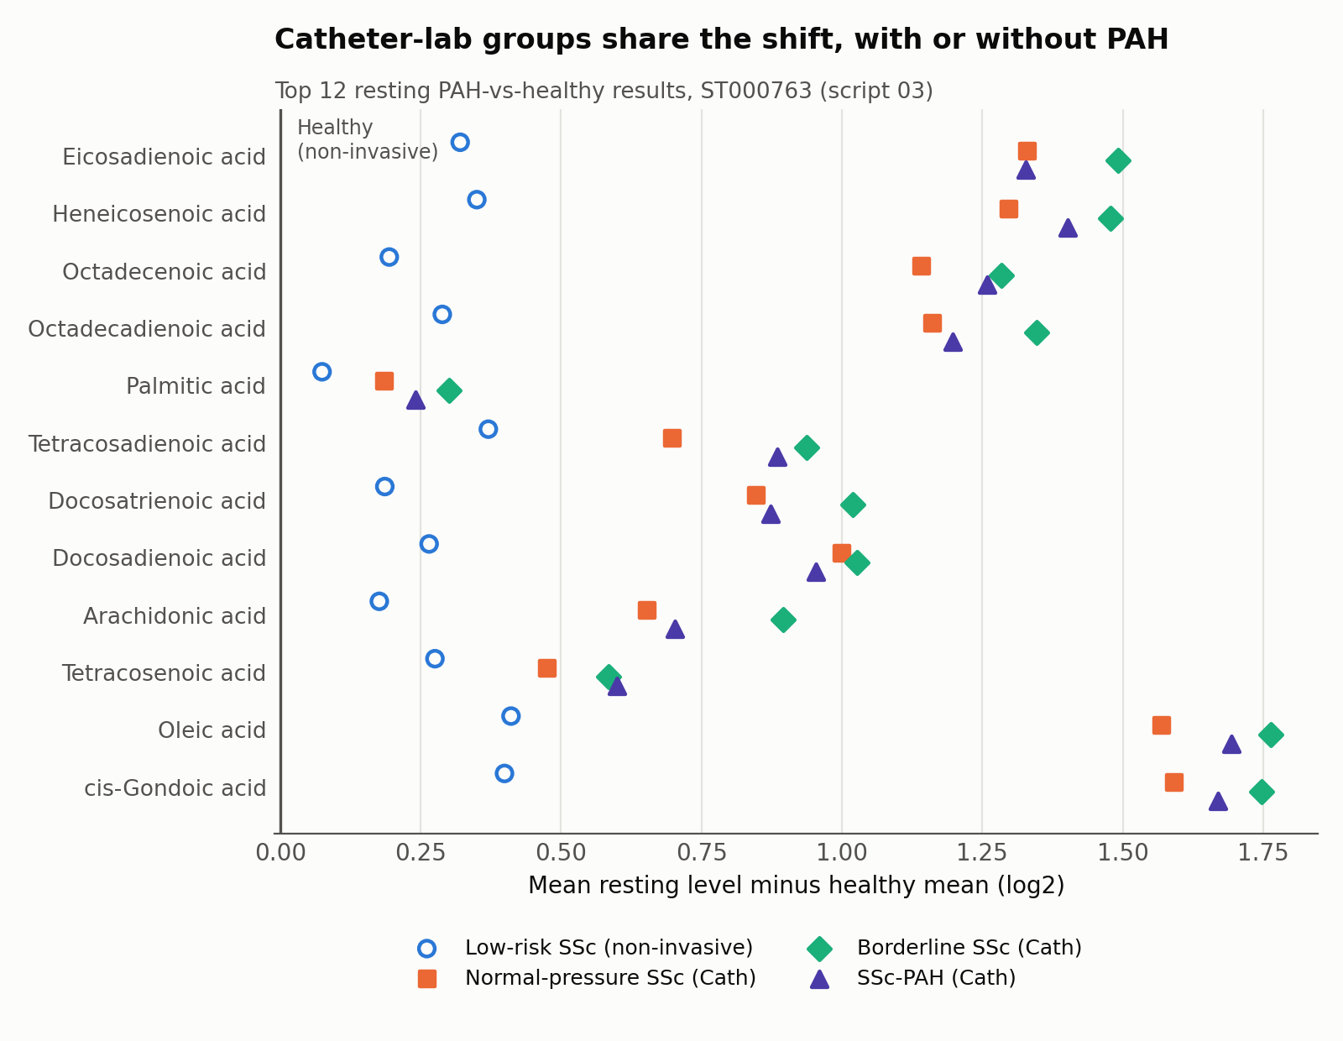

Adding a paper's metabolite list
Save a CSV in data/pah_metabolite_lists/ and rerun script 06. Columns: list_id, source, source_type (paper_reported or our_reanalysis), comparison, metabolite_name, refmet_name (use the Workbench RefMet name converter), pah_log2_effect, pah_direction (up/down), pah_q_value, is_reported_hit (True = PAH-altered, False = background) and caveat. Without False background rows, each marker is still annotated, but you cannot say PAH markers are more exercise-sensitive than metabolites in general.

Run it
Python 3.10+ with requirements.txt; R 4.4+ with MotrpacHumanPreSuspensionAnalysis 2.0.8 for step 04. From any folder: python run_pipeline.py. Add --r-library PATH if the package is in its own library, or --skip-r to reuse the bundled MoTrPAC export. Each script also runs on its own after the steps before it. Verified locally with Python 3.12.0 and R 4.4.2.

Concise conclusion
In ST000763, no metabolite's acute exercise response differs between SSc-PAH and healthy people or other SSc groups. At rest, PAH differs strongly from healthy people, but normal-pressure SSc sampled in the same catheterization setting shows almost the same differences, and PAH versus that group gives none. MoTrPAC shows these metabolites are mostly stable in healthy people, with or without exercise, and the resting differences are several times larger than normal drift. So recent exercise or time of day does not explain them; sampling setting and/or scleroderma is the leading explanation, not PAH. Practical message for PAH metabolite biomarkers: match sampling conditions and record recent activity. These are cross-study descriptions from inferred pairs and public labels, not proof of mechanism.

